GRADES 1 to 12  DAILY LESSON LOG | School: |  | Grade Level: | VI
 | Teacher: |  | Learning Area: | MATHEMATICS
 | Teaching Dates and Time: | (WEEK 8) | Quarter: | 1st Quarter

 | MONDAY | TUESDAY | WEDNESDAY | THURSDAY | FRIDAY
I. OBJECTIVES
A. Content Standard | The learner demonstrates understanding of the four fundamental operations involving fractions and decimals.
B. Performance Standard | The learner is able to apply the four fundamental operations involving fractions and decimals in mathematical problems and real-life situations.
C. Learning Competencies / Objectives | Divides decimals up to 2 decimal places by 10, 100 and 1000 mentally M6NS-Ih-118 | Divides decimals up to 2 decimal places by 10, 100 and 1000 mentally M6NS-Ih-118 | Differentiates terminating from repeating, non-terminating decimal quotients M6NS-Ii-119 |  | Conduct Weekly Test
II. CONTENT
III. LEARNING RESOURCES
- References
1. Teacher’s Guide pages | Math 6 TG p. 91-94 | Lesson Guide in Elementary Mathematics 6 p. 125-127 | Lesson Guide in Elementary Mathematics 6 p. 111-114
2. Learner’s Materials pages
3. Textbook pages
4. Additional Materials from Learning Resource (LR) Portal
- Other Learning Resources
IV. PROCEDURES
A. Reviewing previous lesson or presenting the new lesson | Checking of assignment.  Ask: When multiplying decimals by 10, 100 and 1000, what do we do with the decimal points?  To what direction do we move the decimal points? | Checking of assignment. | Prepare the following problems on separate sheets.  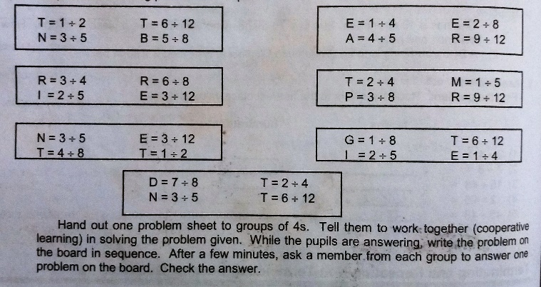 |  | Prepare the pupils by giving them the standards in taking the test.
B. Establishing a purpose for the lesson | Present this problem to the class.  One day, Grandma ask her twin granddaughters Myra and Mia to pack 28.67 kg chicharon in 10 small packs. How many kg. of chicharon did each pack have? The one who can answer orally will receive ₱30 as a gift. Myra’s answer is 2.867 kg while Mia’s answer is 0.2867 chicharon.  Who got the correct answer?  Infuse the value of alertness in every undertakings. | Study the following sets of equation.  Set A Set B  450 ÷ 10 = 45 450 ÷ 100 = 4.5 450 ÷ 1000 = 0.45 2.8 ÷ 10 = 0.28 2.8 ÷ 100 = 0.028 2.8 ÷ 1000 = 0.0028  What do you notice in each set?  Is there a pattxxern? | Post the following on the board.  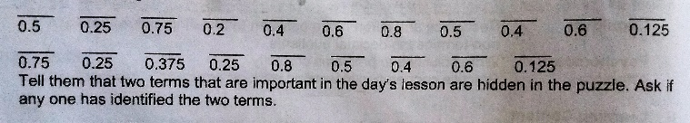 |  | Test Proper
C.Presenting Examples/Instances of new lesson | Show to the class the flow charts, study it.  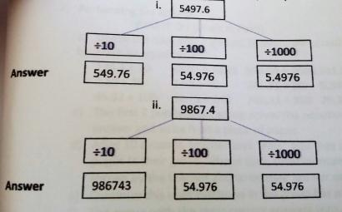  What happens to the decimal point in the examples above? Towards what direction does it move?  Is there a pattern in the movement of the decimal point? | Discuss the rules/steps in dividing whole numbers or decimals by 10, 100 and 1000. Give more examples.  - 42.7 ÷ 10 =  - 5.6 ÷ 100 =  - 3.4 ÷ 1000 =  Elicit pattern from the students. | Activity 1  1. Have the pupils examine their solutions to the problem sheets during the review. Lead them to notice that the last remainder is zero. Tell them that the decimal quotients of these problems are called terminating decimals.  2. Hand out another set of problem sheets to be solved.  (refer to TG)  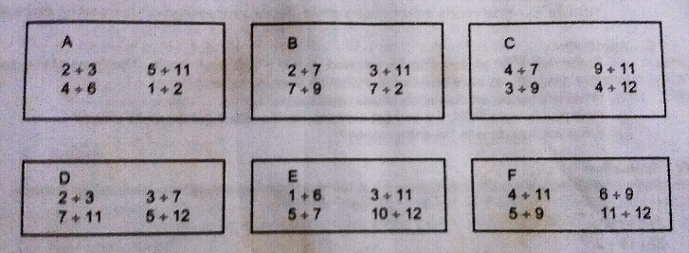  3. Have volunteers from each group show their solutions on the board. Discuss the solutions given. Ask for their observations.  4. Lead them to say that the decimal quotient is a repeating decimal.  5. Have an open discussion on the difference between terminating and repeating/non-terminating decimals.
D. Discussing new concepts and practicing new skills #1 | Solve mentally.  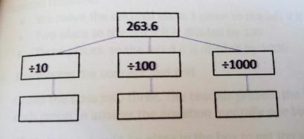  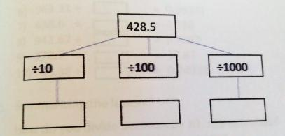 | Divide the class into 6 groups (per column)  a. Flash an equation, say, 92.3 ÷ 100 =  b. The first student in the group solves the equation mentally and writes the answer on a piece of paper.  c. After 10 seconds, the teacher says “ PASS” and he/she passes the paper to the next one in his/her group, who in turn solves mentally the equation that will be shown by the teacher, and writes his/her answer on the same piece of paper.  d. Continue this until everyone in the group has participated.
E. Discussing new concepts and practicing new skills #2 | Solve orally.  - 193.4 ÷ 10  - 2.10 ÷ 10  - 46.32 ÷ 100  - 63.81 ÷ 1000  - 42.71 ÷ 100 |  | Activity 2  1. Tell the pupils to write 5 numbers on their papers. Shuffle cards with numbers 3 to 9 written to them. Ask a member from each group to pick a card. The number picked will be the divisor.  2. Tell the class that the group can already write their solution on the board once they finish. Have a volunteer from each group to explain their answer to the class.  3. Have them look again to the solution on the board. Teel the pupils to place the decimal quotients under the two columns.  Ends in Zeros Continuous  (refer to TG p.113)
F. Developing mastery  (Leads to Formative Assessment | Group the class into 3. Present the following exercises and call each group to answer the equation mentally one by one.  - 53.8 ÷ ______ = 0.538  - 197.2 ÷ _____ = 1.972  - 46.38 ÷ _____ = 0.04638  - 793.81 ÷ _____ = 79.381  - 842.6 ÷______ = 8.426  - 963.31÷_____ = 0.96331  - 438.6 ÷ _____ = 4.386  - 942.67 ÷ _____ = 9.4267  - 378.7 ÷ _____ = 37.87  - 749.38 ÷_____= 0.74938 | Divide mentally.  34.5 ÷ 10 = n  28.6 ÷ 100 = n  58.33 ÷ 1000 = n  248.32 ÷ 10 = n  762.425 ÷ 100 = n | Solve and identify if the decimal quotient is a terminating or repeating/non-terminating decimal.  a) 1 ÷ 13  b) 2 ÷ 13  c) 3 ÷ 13  d) 4 ÷ 13  e) 5 ÷ 13 | Solve and identify if the decimal quotient is a terminating or repeating/non-terminating decimal.  a) 6 ÷ 13  b) 7 ÷ 13  c) 8 ÷ 13  d) 9 ÷ 13  e) 10 ÷ 13
G. Finding practical applications of concepts and skills in daily living | Solve the following orally.  - 425. 9 ÷ 10  - 438.61 ÷ 100  - 768.38 ÷ 1000  - 29.38 ÷ 100  - 9.38 ÷ 100 | Mr. Sawan has ₱3,345.85, he wants to give it to the children who helped him clean his tricycles. How much will each child receive if there are ten children who helped him? | Father left ₱50 on the table for you and your brothers’ snack. The three of you decided to share it equally so each one can buy what he likes for a snack.  1) What will be the amount each of you can receive?  2) How much from ₱50, will you set aside so each one will get an equal share?  3) What will you do with the extra money? | Mother gave ₱70 for you and your brothers’ snack. The three of you decided to share it equally so each one can buy what he likes for a snack.  1) What will be the amount each of you can receive?  2) How much from ₱70, will you set aside so each one will get an equal share?  3) What will you do with the extra money?
H. Making generalizations and abstractions about the lesson | How do you divide decimals by 10,100 and 1000? | How do you divide decimals by 10,100 and 1000? | How do you differentiate a terminating decimal to a repeating/non-terminating decimal? | How do you differentiate a terminating decimal to a repeating/non-terminating decimal?
I. Evaluating Learning | Give the answers mentally as fast as you can.  - 63.8 ÷ 10  - 56.51 ÷ 100  - 24.73 ÷ 100  - 34.83 ÷ 10  - 149.2 ÷ 1000 | Give the answers mentally as fast as you can?  1. 63.8 ÷ 10 =  2. 56.51 ÷ 100 =  3. 635.2 ÷ 1000 =  4. 424.6 ÷ 10 =  5. 2473 ÷ 100 = | Solve and identify if the decimal quotient is a terminating or repeating/non-terminating decimal.  1) 7 ÷ 4  2) 15 ÷ 9  3) 11 ÷ 2  4) 3 ÷ 16  5) 6 ÷ 21 | Solve and identify if the decimal quotient is a terminating or repeating/non-terminating decimal.  1) 9 ÷ 5  2) 14 ÷ 8  3) 7 ÷ 11  4) 4 ÷ 17  5) 5 ÷ 21
J. Additional activities for application and remediation | Complete the table below. Find the quotient.  ÷10 ÷100 ÷1000  1. 14.8  2. 263.32  3. 129.74  4. 88.29  5. 212.73 | Complete the table below.  Decimals ÷10 ÷100 ÷1000  14.8  27.632  129.74  376.24  88.29 | Solve and identify if the decimal quotient is a terminating or repeating/non-terminating decimal.  1) 3 ÷ 20  2) 6 ÷ 11  3) 20 ÷ 12  4) 2 ÷ 6  5) 81 ÷ 48 | Choose a number as a divisor. Use any ten numbers as your dividend. Solve for the quotient. Identify the quotient if it is a terminating/non-terminating.
V. REMARKS
VI. REFLECTIONS
A. No. of learners who earned 80% on the formative assessment
B. No. of learners who require additional activities for remediation who scored below 80%
C. Did the remedial lessons work? No. of learners who have caught up with the lesson
D. No. of learners who continue to require remediation
E. Which of my teaching strategies worked well? Why did this work?
F. What difficulties did I encountered which my principal or supervisor can help me solve?
G. What innovation or localized materials did I use/discover which I wish to share with other teachers?

Prepared by:
Sweet Formula Contributor

